CS223 Lab Project

Altay İlker Yiğitel

CS223 Sec: 01

22203024

I have implemented the uart using main modules and connecting modules which are baud controller uart receiver transmitter debouncers seg7 displays and fifos connecting rx’s and tx’s. UART allows me to send and receive data from and to another device. It sends and receives data in bytes. There are 1 stop bit, 1 start bit and 1 parity bit.

Uart top

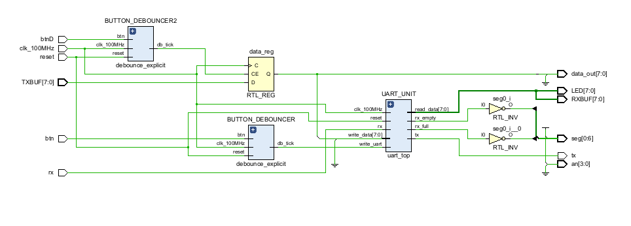

Uart

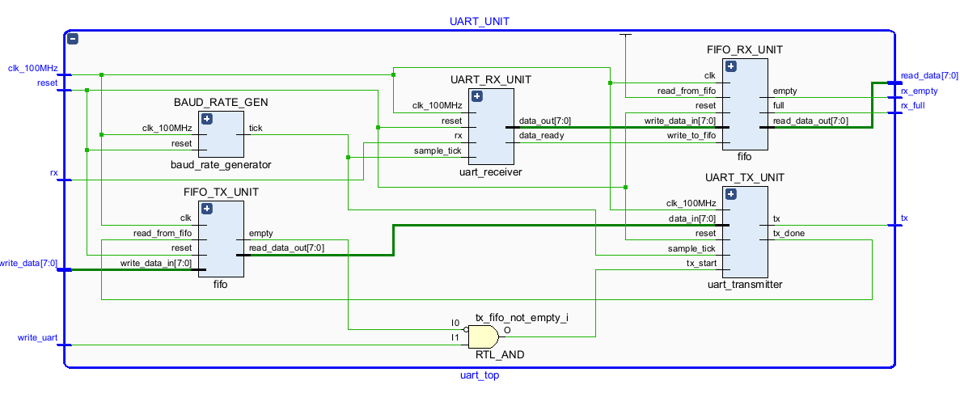

TX

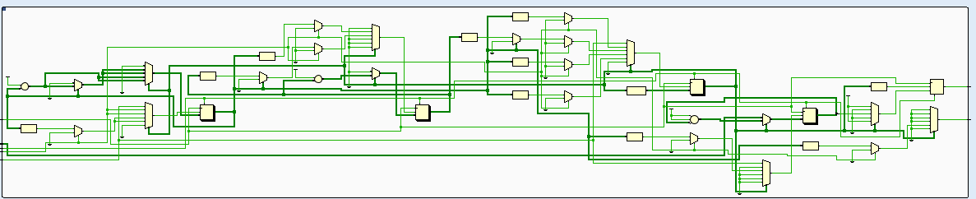

RX

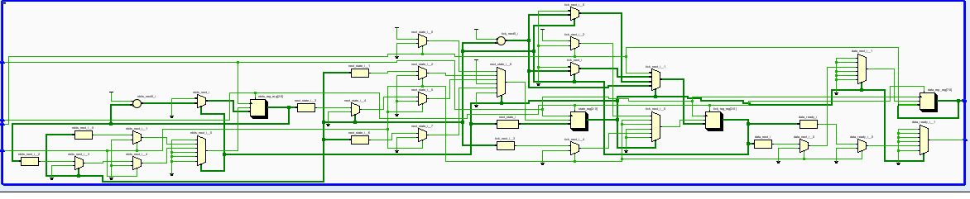

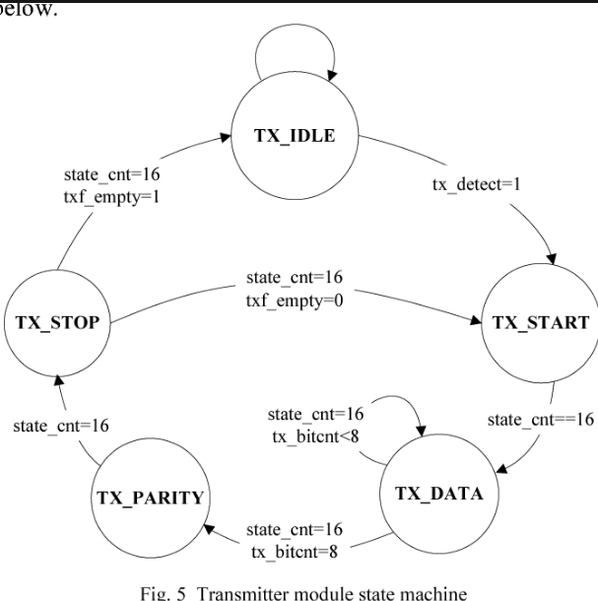

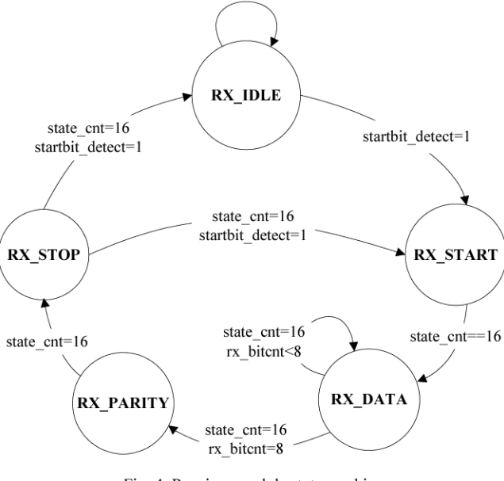

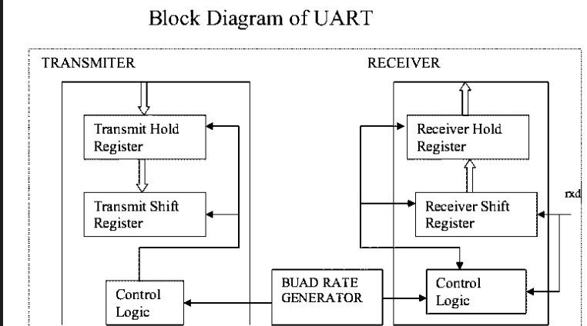

module uart_test(

input clk_100MHz, // basys 3 FPGA clock signal

input reset, // btnR

input rx, // USB-RS232 Rx

input btn, // btnL (read and write FIFO operation)

input btnD,

input btnU,

input btnL,

input [7:0] TXBUF,

output tx, // USB-RS232 Tx

output [3:0] an, // 7 segment display digits

output [0:6] seg, // 7 segment display segments

output [7:0] LED, // data byte display

output [7:0] data_out,

output reg [7:0] RXBUF

);

bit [7:0] hxxt[4];

bit [7:0] hxxr[4];

reg lastr = 0;

reg data;

reg [3:0] sec_ones = 0;

reg [3:0] sec_tens = 0;

reg [3:0] sec_hundereds = 0;

reg [3:0] sec_thousands = 0;

// Connection Signals

wire rx_full, rx_empty, btn_tick,btn_tick2,btn_tick3,btn_tick4;

wire [7:0] rec_data, rec_data1;

initial begin

for(int i = 0;i<$size(hxxt);i++)begin

hxxt[i] = 0;

hxxr[i] = 0;

end

end

always @(posedge clk_100MHz)

if(btn_tick2)

data = TXBUF;

always@(posedge clk_100MHz)

if(hxxt[0] == 0 && ~rx)begin

for(int i = $size(hxxt)-2;i>=0;i--)begin

hxxt[i] = hxxt[i+1];

end

hxxt[0] = TXBUF;

end

always@(posedge clk_100MHz)

if(hxxr[0] == 0 && btn_tick2)begin

for(int i = $size(hxxt)-2;i>=0;i--)begin

hxxr[i] = hxxr[i+1];

end

hxxr[0] = RXBUF;

if(lastr<3)

lastr++;

end

always@(posedge clk_100MHz)

if(btn_tick3) begin

if(sec_thousands<1)

sec_thousands++;

else

sec_thousands = 0;

end

always@(posedge clk_100MHz)

if(btn_tick4) begin

if(sec_hundereds<3)

sec_hundereds++;

else

sec_hundereds = 0;

end

always@(posedge clk_100MHz)

if(sec_thousands == 0)begin

sec_tens = hxxt[sec_hundereds] [3:0];

sec_ones = hxxt[sec_hundereds] [7:4];

end

else begin

sec_tens = hxxr[sec_hundereds] [3:0];

sec_ones = hxxr[sec_hundereds] [7:4];

end

// Complete UART Core

uart_top UART_UNIT

(

.clk_100MHz(clk_100MHz),

.reset(reset),

//.read_uart(btn_tick),

.write_uart(btn_tick),

.rx(rx),

.write_data(data), //rec_data1

.rx_full(rx_full),

.rx_empty(rx_empty),

.read_data(rec_data),

.tx(tx)

);

// Button Debouncer

debounce_explicit BUTTON_DEBOUNCER

(

.clk_100MHz(clk_100MHz),

.reset(reset),

.btn(btn),

.db_level(),

.db_tick(btn_tick)

);

debounce_explicit BUTTON_DEBOUNCER2

(

.clk_100MHz(clk_100MHz),

.reset(reset),

.btn(btnD),

.db_level(),

.db_tick(btn_tick2)

);

debounce_explicit BUTTON_DEBOUNCER3

(

.clk_100MHz(clk_100MHz),

.reset(reset),

.btn(btnU),

.db_level(),

.db_tick(btn_tick3)

);

debounce_explicit BUTTON_DEBOUNCER4

(

.clk_100MHz(clk_100MHz),

.reset(reset),

.btn(btnL),

.db_level(),

.db_tick(btn_tick4)

);

seg7_control seg7(.clk_100MHz(clk_100MHz), .reset(res), .ones(sec_ones), .tens(sec_tens), .hundereds(sec_hundereds),

.thousands(sec_thousands), .seg(seg), .an(an));

// Signal Logic

assign rec_data1 = rec_data + 1; // add 1 to ascii value of received data (to transmit)

assign RXBUF = rec_data;

// Output Logic

assign LED = hxxr[lastr]; // data byte received displayed on LEDs

assign data_out = hxxt[0];

Endmodule

module uart_top

#(

parameter DBITS = 8, // number of data bits in a word

SB_TICK = 16, // number of stop bit / oversampling ticks

BR_LIMIT = 52, // baud rate generator counter limit

BR_BITS = 6, // number of baud rate generator counter bits

FIFO_EXP = 2 // exponent for number of FIFO addresses (2^2 = 4)

)

(

input clk_100MHz, // FPGA clock

input reset, // reset

//input read_uart, // button

input write_uart, // button

input rx, // serial data in

input [DBITS-1:0] write_data, // data from Tx FIFO

output rx_full, // do not write data to FIFO

output rx_empty, // no data to read from FIFO

output tx, // serial data out

output [DBITS-1:0] read_data // data to Rx FIFO

);

// Connection Signals

wire tick; // sample tick from baud rate generator

wire rx_done_tick; // data word received

wire tx_done_tick; // data transmission complete

wire tx_empty; // Tx FIFO has no data to transmit

wire tx_fifo_not_empty; // Tx FIFO contains data to transmit

wire [DBITS-1:0] tx_fifo_out; // from Tx FIFO to UART transmitter

wire [DBITS-1:0] rx_data_out; // from UART receiver to Rx FIFO

// Instantiate Modules for UART Core

baud_rate_generator

#(

.M(BR_LIMIT),

.N(BR_BITS)

)

BAUD_RATE_GEN

(

.clk_100MHz(clk_100MHz),

.reset(reset),

.tick(tick)

);

uart_receiver

#(

.DBITS(DBITS),

.SB_TICK(SB_TICK)

)

UART_RX_UNIT

(

.clk_100MHz(clk_100MHz),

.reset(reset),

.rx(rx),

.sample_tick(tick),

.data_ready(rx_done_tick),

.data_out(rx_data_out)

);

uart_transmitter

#(

.DBITS(DBITS),

.SB_TICK(SB_TICK)

)

UART_TX_UNIT

(

.clk_100MHz(clk_100MHz),

.reset(reset),

.tx_start(tx_fifo_not_empty),

.sample_tick(tick),

.data_in(tx_fifo_out),

.tx_done(tx_done_tick),

.tx(tx)

);

fifo

#(

.DATA_SIZE(DBITS),

.ADDR_SPACE_EXP(FIFO_EXP)

)

FIFO_RX_UNIT

(

.clk(clk_100MHz),

.reset(reset),

.write_to_fifo(rx_done_tick),

.read_from_fifo(1'b1), //read_uart

.write_data_in(rx_data_out),

.read_data_out(read_data),

.empty(rx_empty),

.full(rx_full)

);

fifo

#(

.DATA_SIZE(DBITS),

.ADDR_SPACE_EXP(FIFO_EXP)

)

FIFO_TX_UNIT

(

.clk(clk_100MHz),

.reset(reset),

.write_to_fifo(write_uart2),

.read_from_fifo(tx_done_tick),

.write_data_in(write_data),

.read_data_out(tx_fifo_out),

.empty(tx_empty),

.full() // intentionally disconnected

);

// debounce_explicit debounce1(

// .clk_100MHz(clk_100MHz),

// .reset(reset),

// .btn(write_uart),

// .db_level(),

// .db_tick(write_uart2)

// );

// Signal Logic

assign tx_fifo_not_empty = ~tx_empty && write_uart;

Endmodule

module baud_rate_generator

#( // 115200 baud

parameter N = 6, // number of counter bits

M = 52 // counter limit value

)

(

input clk_100MHz, // basys 3 clock

input reset, // reset

output tick // sample tick

);

// Counter Register

reg [N-1:0] counter; // counter value

wire [N-1:0] next; // next counter value

// Register Logic

always @(posedge clk_100MHz, posedge reset)

if(reset)

counter <= 0;

else

counter <= next;

// Next Counter Value Logic

assign next = (counter == (M-1)) ? 0 : counter + 1;

// Output Logic

assign tick = (counter == (M-1)) ? 1'b1 : 1'b0;

Endmodule

module uart_receiver

#(

parameter DBITS = 8, // number of data bits in a data word

SB_TICK = 16 // number of stop bit / oversampling ticks (1 stop bit)

)

(

input clk_100MHz, // basys 3 FPGA

input reset, // reset

input rx, // receiver data line

input sample_tick, // sample tick from baud rate generator

output reg data_ready, // signal when new data word is complete (received)

output [DBITS-1:0] data_out // data to FIFO

);

// State Machine States

localparam [2:0] idle = 3'b000,

start = 3'b001,

data = 3'b010,

stop = 3'b011,

parity = 3'b100;

// Registers

reg [2:0] state, next_state; // state registers

reg [3:0] tick_reg, tick_next; // number of ticks received from baud rate generator

reg [2:0] nbits_reg, nbits_next; // number of bits received in data state

reg [7:0] data_reg, data_next; // reassembled data word

// Register Logic

always @(posedge clk_100MHz, posedge reset)

if(reset) begin

state <= idle;

tick_reg <= 0;

nbits_reg <= 0;

data_reg <= 0;

end

else begin

state <= next_state;

tick_reg <= tick_next;

nbits_reg <= nbits_next;

data_reg <= data_next;

end

// State Machine Logic

always @* begin

next_state = state;

data_ready = 1'b0;

tick_next = tick_reg;

nbits_next = nbits_reg;

data_next = data_reg;

case(state)

idle:

if(~rx) begin // when data line goes LOW (start condition)

next_state = start;

tick_next = 0;

end

start:

if(sample_tick)

if(tick_reg == 7) begin

next_state = data;

tick_next = 0;

nbits_next = 0;

end

else

tick_next = tick_reg + 1;

data:

if(sample_tick)

if(tick_reg == 15) begin

tick_next = 0;

data_next = {rx, data_reg[7:1]};

if(nbits_reg == (DBITS-1))

next_state = stop;

else

nbits_next = nbits_reg + 1;

end

else

tick_next = tick_reg + 1;

parity: begin

;

next_state = stop;

end

stop:

if(sample_tick)

if(tick_reg == (SB_TICK-1)) begin

next_state = idle;

data_ready = 1'b1;

end

else

tick_next = tick_reg + 1;

endcase

end

// Output Logic

assign data_out = data_reg;

Endmodule

module uart_transmitter

#(

parameter DBITS = 8, // number of data bits

SB_TICK = 16 // number of stop bit / oversampling ticks (1 stop bit)

)

(

input clk_100MHz, // basys 3 FPGA

input reset, // reset

input tx_start, // begin data transmission (FIFO NOT empty)

input sample_tick, // from baud rate generator

input [DBITS-1:0] data_in, // data word from FIFO

output reg tx_done, // end of transmission

output tx // transmitter data line

);

// State Machine States

localparam [2:0] idle = 3'b000,

start = 3'b001,

data = 3'b010,

stop = 3'b011,

parity = 3'b100;

// Registers

reg [2:0] state, next_state; // state registers

reg [3:0] tick_reg, tick_next; // number of ticks received from baud rate generator

reg [2:0] nbits_reg, nbits_next; // number of bits transmitted in data state

reg [DBITS-1:0] data_reg, data_next; // assembled data word to transmit serially

reg tx_reg, tx_next; // data filter for potential glitches

// Register Logic

always @(posedge clk_100MHz, posedge reset)

if(reset) begin

state <= idle;

tick_reg <= 0;

nbits_reg <= 0;

data_reg <= 0;

tx_reg <= 1'b1;

end

else begin

state <= next_state;

tick_reg <= tick_next;

nbits_reg <= nbits_next;

data_reg <= data_next;

tx_reg <= tx_next;

end

// State Machine Logic

always @* begin

next_state = state;

tx_done = 1'b0;

tick_next = tick_reg;

nbits_next = nbits_reg;

data_next = data_reg;

tx_next = tx_reg;

case(state)

idle: begin // no data in FIFO

tx_next = 1'b1; // transmit idle

if(tx_start) begin // when FIFO is NOT empty

next_state = start;

tick_next = 0;

data_next = data_in;

end

end

start: begin

tx_next = 1'b0; // start bit

if(sample_tick)

if(tick_reg == 15) begin

next_state = data;

tick_next = 0;

nbits_next = 0;

end

else

tick_next = tick_reg + 1;

end

data: begin

tx_next = data_reg[0];

if(sample_tick)

if(tick_reg == 15) begin

tick_next = 0;

data_next = data_reg >> 1;

if(nbits_reg == (DBITS-1))

next_state = parity;

else

nbits_next = nbits_reg + 1;

end

else

tick_next = tick_reg + 1;

end

parity: begin

tx_next = 1'b0;

if(sample_tick)

if(tick_reg == (SB_TICK-1)) begin

next_state = stop;

end

else

tick_next = tick_reg + 1;

end

stop: begin

tx_next = 1'b1; // back to idle

if(sample_tick)

if(tick_reg == (SB_TICK-1)) begin

next_state = idle;

tx_done = 1'b1;

end

else

tick_next = tick_reg + 1;

end

endcase

end

// Output Logic

assign tx = tx_reg;

Endmodule

module fifo

#(

parameter DATA_SIZE = 8, // number of bits in a data word

ADDR_SPACE_EXP = 4 // number of address bits (2^4 = 16 addresses)

)

(

input clk, // FPGA clock

input reset, // reset button

input write_to_fifo, // signal start writing to FIFO

input read_from_fifo, // signal start reading from FIFO

input [DATA_SIZE-1:0] write_data_in, // data word into FIFO

output [DATA_SIZE-1:0] read_data_out, // data word out of FIFO

output empty, // FIFO is empty (no read)

output full // FIFO is full (no write)

);

// signal declaration

reg [DATA_SIZE-1:0] memory [2**ADDR_SPACE_EXP-1:0]; // memory array register

reg [ADDR_SPACE_EXP-1:0] current_write_addr, current_write_addr_buff, next_write_addr;

reg [ADDR_SPACE_EXP-1:0] current_read_addr, current_read_addr_buff, next_read_addr;

reg fifo_full, fifo_empty, full_buff, empty_buff;

wire write_enabled;

// register file (memory) write operation

always @(posedge clk)

if(write_enabled)

memory[current_write_addr] <= write_data_in;

// register file (memory) read operation

assign read_data_out = memory[current_read_addr];

// only allow write operation when FIFO is NOT full

assign write_enabled = write_to_fifo & ~fifo_full;

// FIFO control logic

// register logic

always @(posedge clk or posedge reset)

if(reset) begin

current_write_addr <= 0;

current_read_addr <= 0;

fifo_full <= 1'b0;

fifo_empty <= 1'b1; // FIFO is empty after reset

end

else begin

current_write_addr <= current_write_addr_buff;

current_read_addr <= current_read_addr_buff;

fifo_full <= full_buff;

fifo_empty <= empty_buff;

end

// next state logic for read and write address pointers

always @* begin

// successive pointer values

next_write_addr = current_write_addr + 1;

next_read_addr = current_read_addr + 1;

// default: keep old values

current_write_addr_buff = current_write_addr;

current_read_addr_buff = current_read_addr;

full_buff = fifo_full;

empty_buff = fifo_empty;

// Button press logic

case({write_to_fifo, 1'b1}) // check both buttons

// 2'b00: neither buttons pressed, do nothing

2'b01: // read button pressed?

if(~fifo_empty) begin // FIFO not empty

current_read_addr_buff = next_read_addr;

full_buff = 1'b0; // after read, FIFO not full anymore

if(next_read_addr == current_write_addr)

empty_buff = 1'b1;

end

2'b10: // write button pressed?

if(~fifo_full) begin // FIFO not full

current_write_addr_buff = next_write_addr;

empty_buff = 1'b0; // after write, FIFO not empty anymore

if(next_write_addr == current_read_addr)

full_buff = 1'b1;

end

2'b11: begin // write and read

current_write_addr_buff = next_write_addr;

current_read_addr_buff = next_read_addr;

end

endcase

end

// output

assign full = fifo_full;

assign empty = fifo_empty;

Endmodule

module debounce_explicit(

input clk_100MHz,

input reset,

input btn, // button input

output reg db_level, // for switches

output reg db_tick // for buttons

);

// state declarations

parameter [1:0] zero = 2'b00,

wait0 = 2'b01,

one = 2'b10,

wait1 = 2'b11;

// Artix-7 has a 100MHz clk with a period of 10ns

// number of counter bits (2^N * 10ns = ~40ms)

parameter N = 22;

// signal declaration

reg [1:0] state_reg, next_state;

reg [N-1:0] q_reg;

wire [N-1:0] q_next;

wire q_zero;

reg q_load, q_dec;

// body

// FSMD state and data registers

always @(posedge clk_100MHz or posedge reset)

if(reset) begin

state_reg <= zero;

q_reg <= 0;

end

else begin

state_reg <= next_state;

q_reg <= q_next;

end

// FSMD data path (counter) next state logic

assign q_next = (q_load) ? {N{1'b1}} : // load all 1s

(q_dec) ? q_reg - 1 : // decrement

q_reg; // no change in q

// status signal

assign q_zero = (q_next == 0);

// FSMD control path next state logic

always @* begin

next_state = state_reg;

q_load = 1'b0;

q_dec = 1'b0;

db_tick = 1'b0;

case(state_reg)

zero : begin

db_level = 1'b0;

if(btn) begin

next_state = wait1;

q_load = 1'b1;

end

end

wait1 : begin

db_level = 1'b0;

if(btn) begin

q_dec = 1'b1;

if(q_zero) begin

next_state = one;

db_tick = 1'b1;

end

end

else

next_state = zero;

end

one : begin

db_level = 1'b1;

if(~btn) begin

q_dec = 1'b1;

if(q_zero)

next_state = zero;

end

else

next_state = one;

end

default : next_state = zero;

endcase

end

Endmodule

module seg7_control(

input clk_100MHz,

input reset,

input [3:0] ones,

input [3:0] tens,

input [3:0] hundereds,

input [3:0] thousands,

output reg [0:6] seg,

output reg [3:0] an

);

// Parameters for segment values

parameter NULL = 7'b111_1111; // Turn off all segments

parameter ZERO = 7'b000_0001; // 0

parameter ONE = 7'b100_1111; // 1

parameter TWO = 7'b001_0010; // 2

parameter THREE = 7'b000_0110; // 3

parameter FOUR = 7'b100_1100; // 4

parameter FIVE = 7'b010_0100; // 5

parameter SIX = 7'b010_0000; // 6

parameter SEVEN = 7'b000_1111; // 7

parameter EIGHT = 7'b000_0000; // 8

parameter NINE = 7'b000_0100; // 9

parameter F = 7'b011_1000; //F;

parameter E = 7'b011_0000; //E;

parameter d = 7'b100_0010; //d;

parameter c = 7'b111_0010; //c;

parameter b = 7'b110_0000; //b;

parameter A = 7'b000_1000; //A;

parameter t = 7'b111_1000; //t;

parameter r = 7'b111_1010; //r;

// To select each anode in turn

reg [1:0] anode_select;

reg [16:0] anode_timer;

always @(posedge clk_100MHz or posedge reset) begin

if(reset) begin

anode_select <= 0;

anode_timer <= 0;

end

else

if(anode_timer == 99_999) begin

anode_timer <= 0;

anode_select <= anode_select + 1;

end

else

anode_timer <= anode_timer + 1;

end

always @(anode_select) begin

case(anode_select)

2'b00 : an = 4'b0111;

2'b01 : an = 4'b1011;

2'b10 : an = 4'b1101;

2'b11 : an = 4'b1110;

endcase

end

// To drive the segments

always @*

case(anode_select)

2'b00 : begin

case(thousands)

4'b0000 : seg = t;

4'b0001 : seg = r;

endcase

end

2'b01 : begin

case(hundereds)

4'b0000 : seg = ZERO;

4'b0001 : seg = ONE;

4'b0010 : seg = TWO;

4'b0011 : seg = THREE;

endcase

end

2'b10 : begin

case(tens)

4'b0000 : seg = ZERO;

4'b0001 : seg = ONE;

4'b0010 : seg = TWO;

4'b0011 : seg = THREE;

4'b0100 : seg = FOUR;

4'b0101 : seg = FIVE;

4'b0110 : seg = SIX;

4'b0111 : seg = SEVEN;

4'b1000 : seg = EIGHT;

4'b1001 : seg = NINE;

4'b1010 : seg = F;

4'b1011 : seg = E;

4'b1100 : seg = d;

4'b1101 : seg = c;

4'b1110 : seg = b;

4'b1111 : seg = A;

endcase

end

2'b11 : begin

case(ones)

4'b0000 : seg = ZERO;

4'b0001 : seg = ONE;

4'b0010 : seg = TWO;

4'b0011 : seg = THREE;

4'b0100 : seg = FOUR;

4'b0101 : seg = FIVE;

4'b0110 : seg = SIX;

4'b0111 : seg = SEVEN;

4'b1000 : seg = EIGHT;

4'b1001 : seg = NINE;

4'b1010 : seg = F;

4'b1011 : seg = E;

4'b1100 : seg = d;

4'b1101 : seg = c;

4'b1110 : seg = b;

4'b1111 : seg = A;

endcase

end

endcase

Endmodule

References:

Github FGPADude, FGPA Projects. https://github.com/FPGADude/Digital-Design/tree/main/FPGA%20Projects/UART